Assignment-1



Assignment 1: Ensure the script checks if a specific file exists in the current directory. If it exists, print "File exists", otherwise print "File not found".

Shell script code with the name of myfile.sh:
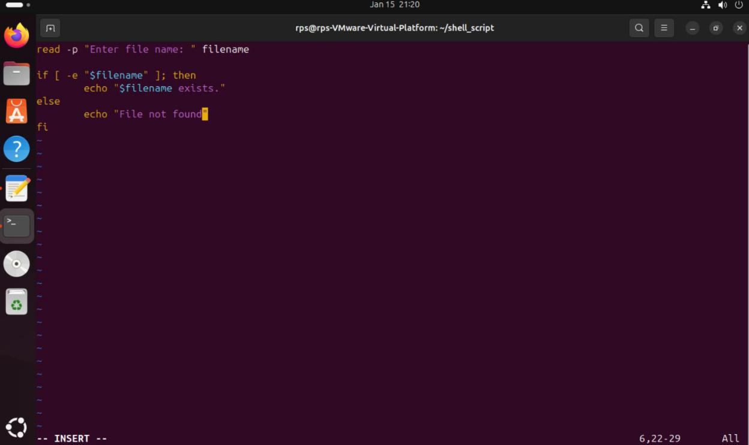

Commands to run myfile.sh and checking its function:
